**Team Lead**

Andrew Andrawos aandrawo@mail.sfsu.edu

**Team Members**

Scott Penn

An Dao

Anita Zhen

Brandon Tong

Nicholas Stepanov

**SW Engineering CSC648/848 Summer 2018**

**StockOverflow**

**Team 4**

**Milestone 2**

**07/07/2018**

# 1. Data Definitions V2

Guest: Unregistered user visiting the website. Can browse through approved postings with only thumbnail representations of content visible, but cannot upload or download content.

User: Registered user who logged into the website with own email and password. User has his own ID that can be used to access a unique user page for the particular user. A User has all the privileges of Guest, in addition can submit Postings and download the content of all Approved Postings. The User can delete any posting uploaded by himself.

Admin: A type of user who was pre-approved by the website management and has all the privileges of a User, in addition can view all Pending Postings and has the privileges to Approve or Reject postings made by users based on their content.

Posting: An individual submission of an image to be posted on the website. The posting is composed of the posting ID, media content (photo), its category and search tags as well as the reference to the author - the user who uploaded the posting. A posting can be visible/invisible to visitors of the website based on its Post Status and visitor type: Guest/User/Admin.

Posting Status: Possible values: Pending, Approved, Rejected. A Pending Posting is visible only to the User who posted it and an Admin. The Admin is able to change the Post Status of a Pending Posting to Approved or Rejected. An Approved Posting is visible to all visitors of the website. A Rejected Posting is only visible to the User who submitted the posting and can be modified and resubmitted or deleted. Once a Rejected Posting is resubmitted its Posting Status is Changed to Pending.

Registration page: The page that prompts a Guest to enter his nickname which is used for login, name and password, as well as an optional description. When all fields are completed with valid entries the Guest can complete the registration and have his information saved in the system. When registration is complete the Guest can log in through Login page with his credentials and become User.

Login page: The page that prompts a Guest to enter previously registered nickname and password. Once Guest enters valid credentials and clicks login button, the Guest will become a User and will be recognized by the system to be granted appropriate privileges.

# 2. Functional Requirements V2

**Priority 1 (P1)**: Critical, do not launch without.

**System**

* (P1) System shall have a homepage.
* (P1) System shall have about pages.
* (P1) System shall have a login page.
* (P1) System shall have a list of categories.
* (P1) System shall have a user page.

**User**

* (P1) User shall be able to do all the functions of the guest.
* (P1) User shall be able to create an account.
  + (P1) User shall be able to download images.
  + (P1) User shall be able to upload images.

**Guest**

* (P1) Guest shall be able to search using image categories.

**Admin**

* (P1) Admin shall be able to do all functions of the user.
* (P1) Admin shall be able to approve pending photos.
* (P1) Admin shall be able to manage photos by directly adding, editing, and deleting.
* (P1) Admin shall be able to manage users and user data.

**Priority 2 (P2)**: Important, it would be really good to have. Don’t delay ship date if not available.

**System**

* (P2) System shall have search bar.

**User**

* (P2) User shall be able to favorite images.
* (P2) User shall be able to rank images.

**Guest**

* (P2) Guest shall be able to search using search bar.

# 3. UI Mockups and Storyboards (high level only)

1. **Home page:**

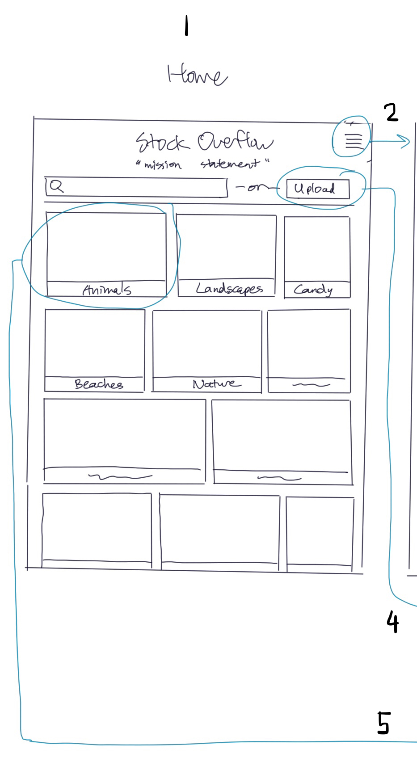

1. **Sliding menu:**

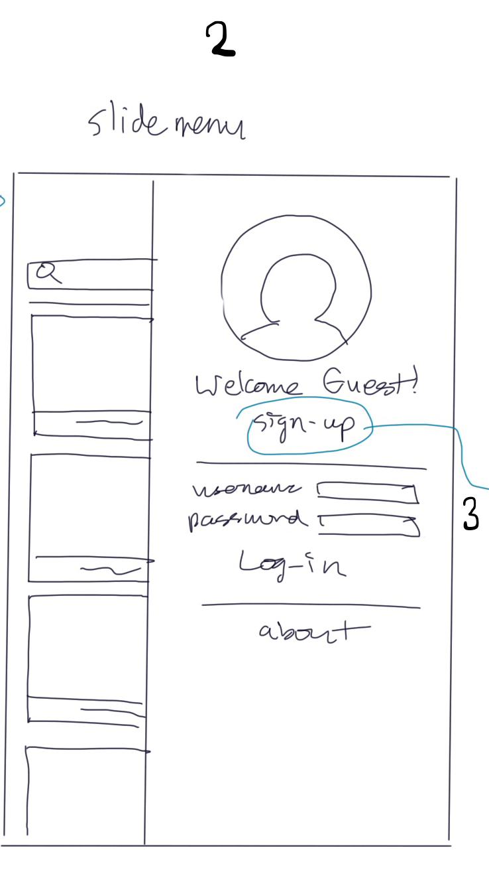

**3.** **Registration page:**

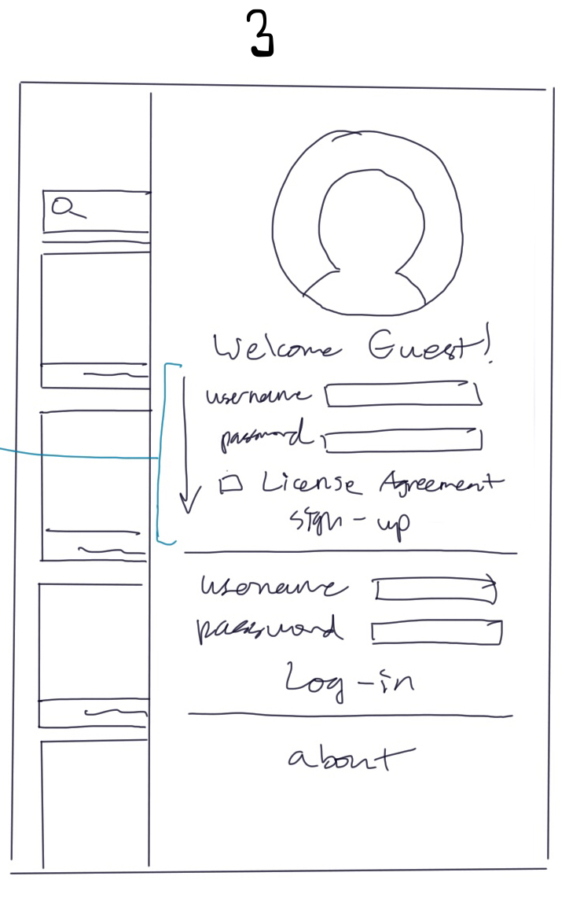

**4. Upload menu:**

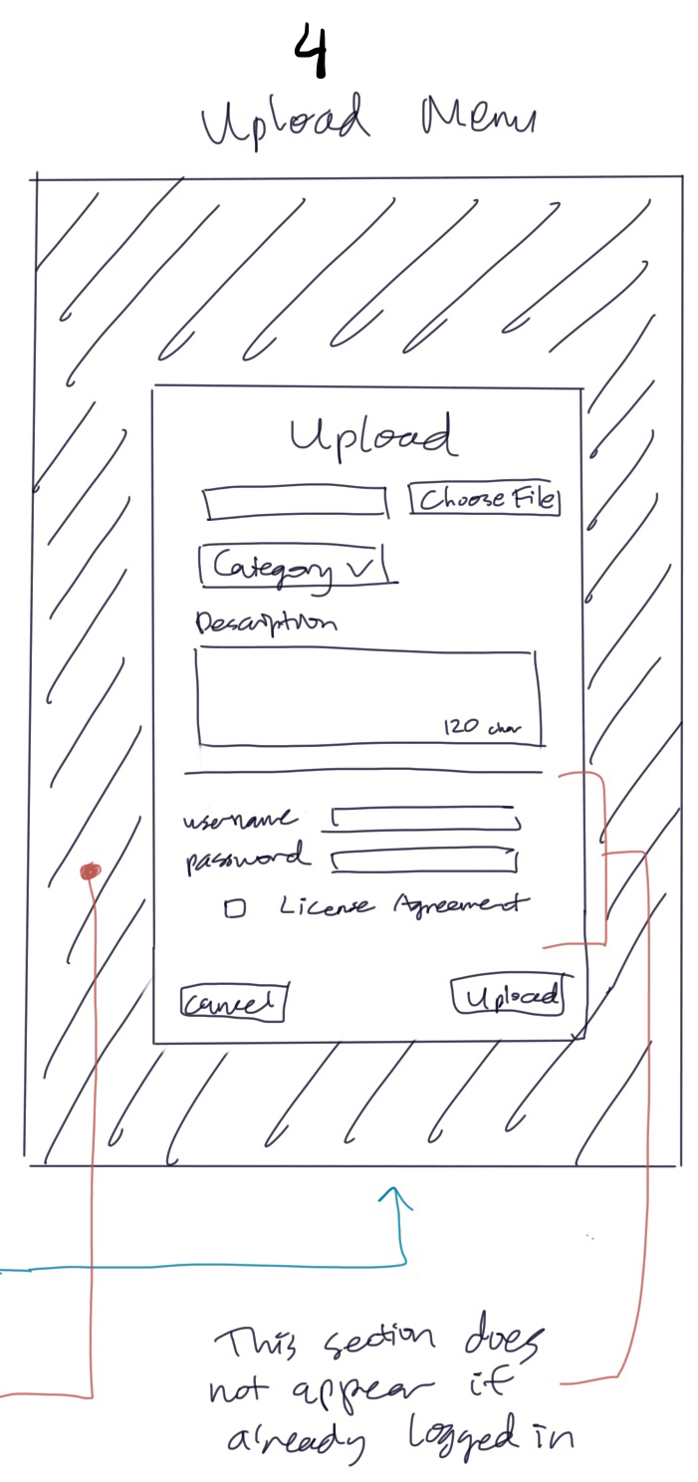

*The background in the upload menu becomes blur or darkened*

**5. Search menu:**

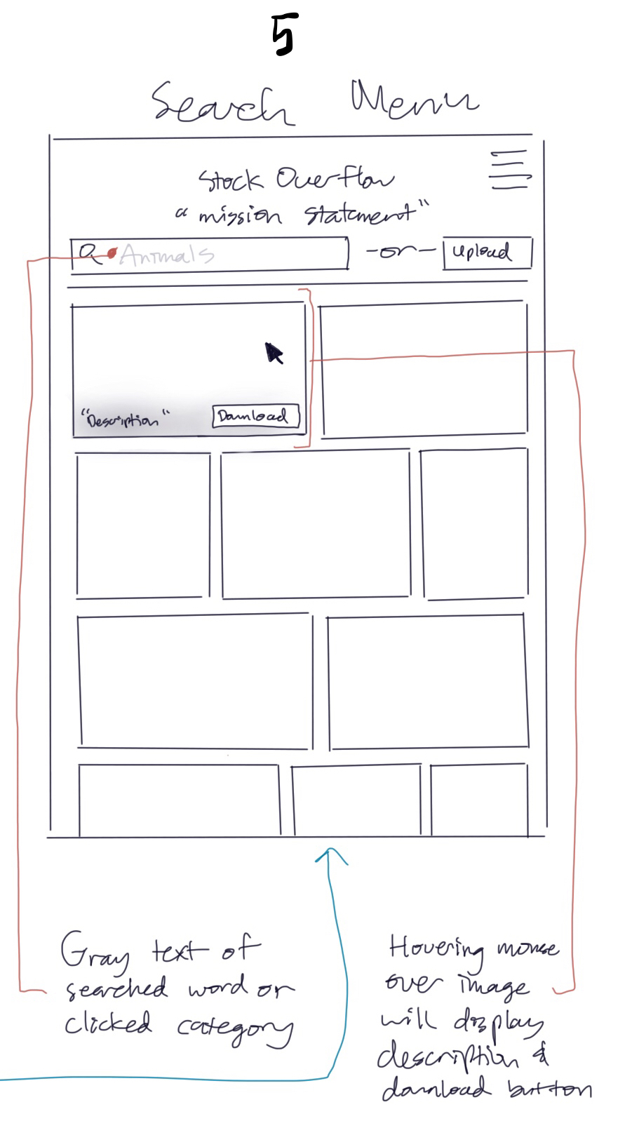

**6. Storyboard:**

A Guest arrives at the Home page (1) of Stock Overflow website through a link. The page gives him the basic understanding of what the website is designed for - Downloading or Uploading images. The Sliding menu (2) which implements User/Admin functionalities is hidden, but Guest can access it by clicking in the right hand corner. Clicking on the “Sign-up” button inside the Sliding menu (2) will pull down the Registration page (3). Clicking “Upload” button will take one to the Upload menu (4) which will ask a Guest to register. A User/Admin will be able to use Upload menu(4) without registration being prompted. One can also access Search menu (5) by clicking on the category or completing a search request through the search bar. Hovering over a particular image will allow download, but will prompt Guest to register using Registration Page (3).

## 4. High level Architecture, Database Organization

**Posting**:

ID (Unique)

Name

Category

Status

User

HighRes

MedRes

Thumbnail

**Category**:

Nature

Animals

Etc.

**Status**:

Approved

Pending

Rejected

**User**:

ID

Username

Password?

Permission Level

**Permission Level**:

Guest

User

Admin

## 

## 5. High Level UML Diagrams (Backend Team)

Class Diagram:

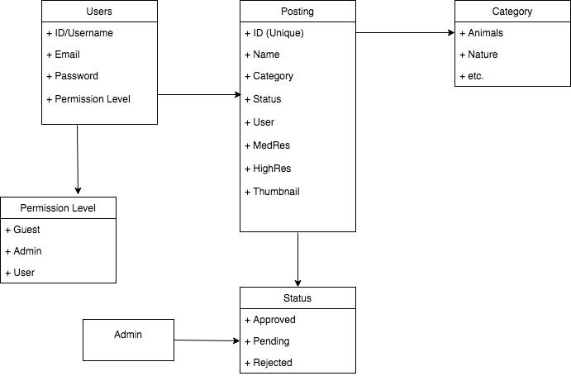

Deployment diagram:

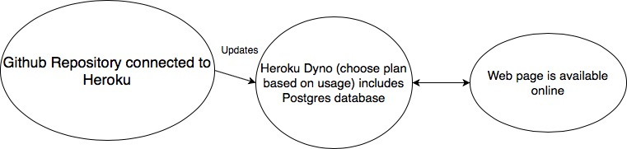

## 

## 6 .Key risks for the project

***skills* risks** (do you have the right skills):

While some team members have a primary focus on web development methodologies, others might need to spend extra time to learn web development concepts and practices required to complete the project.

***schedule* risks** (can you make it given what you committed and the resources):

The schedule for the project is very fast-paced which could result in shipping only the bare minimum requirements (P1) for the project.

***technical* risks** (any technical unknowns to solve):

Heroku was chosen as a complete full-stack system for deploying web content that is well documented in order to minimize chances of encountering critical technical risks that will complicate shipping of the product.

***teamwork* risks** (any issues related to teamwork):

The team members may be busy with their other commitments such as other classes and jobs which will make it harder to find specific time when all of the team members are available to meet other than the regular class meeting.

***legal/content* risks** (can you obtain content/SW you need legally with proper licensing, copyright):

The uploaded content will only be checked by an Admin on having proper content and legal authorization. The procedure of checking for copyrighted images would need to be refined through software automation in order to avoid any possible legal issues.